“Talk’n’Takeout: Voice Recognition Ordering System”

A Capstone Project
Presented to the Faculty of the
College of Information Technology Education
PHINMA University of Iloilo

In Partial Fulfillment
of the Requirements for the degree
Bachelor of Science in Information Technology

s
Group:

“BINARY BISON”

Member:

Jezrel John B.Tolentino
Patrick D.Lopez

April 2026

Approval Sheet
In partial fulfillment of the requirements for the Bachelor of Science in Information Technology, this Capstone Project entitled “Talk’n’Takeout: Text-to-Speech Enabled Voice Ordering System” prepared and submitted by Patrick Lopez and Jezrel Tolentino. Who are hereby recommended for corresponding final evaluation.

Ryan C. Valeriano
Adviser

Approved by the Panel of Evaluators with a grade of PASSED

Dr. Arnold M. Fuentes, Ph. D, MPA, MMIT
Chairman

Andreas V. Armada
Member

Accepted in partial fulfillment of the requirements of the degree Bachelor of Science in Information Technology

Seth dA. Nono, MSCS
CITE, DEAN

Acknowledgement

The researchers wish to express their deepest gratitude to all the people who made this project possible.
To the faculty of the College of Information Technology Education of PHINMA University of Iloilo, for their guidance and support throughout this study.
Special thanks to our Capstone Adviser for the encouragement and valuable feedback that helped refine our work.

We also thank our classmates and friends who assisted us during testing and evaluation.
Lastly, to our families for their endless support, patience, and understanding—thank you for being our source of motivation and strength.
First of all , we are grateful to the Almighty God for establishing us to complete this Capstone Project.
We sincerely thank our Dean, Mr. Seth D. A. Nono , for granting us this opportunity and for providing the necessary facilities that made the completion of our capstone project possible.

The completion of this proposed project would not have been possible without the continuous guidance and support of our Capstone 1 teacher, Dr. Arnold M. Fuentes, Ph.D., MPA, MMIT. We sincerely thank him for his valuable guidance and assistance in helping us successfully complete Capstone 1. We would also like to express our heartfelt gratitude to our Capstone 2 teacher, Mr. Ryan Valeriano, for his guidance, support, and dedication in helping us expand our knowledge while developing this project. Thank you very much, Sir.

To our adviser, Sir Ryan Valeriano, thank you for being a great adviser and mentor. Your passion for teaching is truly inspiring, and we appreciate the time and effort you gave to help us improve. May God bless you.

Abstract

Talk’n’Takeout is an innovative voice-recognition ordering system designed to simplify and enhance the food-ordering experience through seamless, hands-free, voice-activated interaction. By integrating advanced speech recognition, natural language processing (NLP), and real-time order management technologies, the system enables users to place orders effortlessly by simply speaking to a virtual assistant. Whether used in restaurants, drive-thru lanes, kiosks, or mobile devices, Talk’n’Takeout provides a modern, contactless solution that aligns with the growing demand for convenience and automation in the food service industry.

The primary goal of the system is to improve operational efficiency, reduce customer wait times, and minimize human error in order processing. By eliminating the need for manual input, the system helps ensure that orders are captured accurately and processed quickly. Users can interact with the system in a natural, conversational manner—using everyday language to browse menus, ask questions, customize meals, and confirm their selections. This intuitive interaction reduces the learning curve and makes the system accessible to a wide range of users, including those who may not be familiar with traditional digital ordering interfaces.

Additionally, Talk’n’Takeout is designed with adaptability and inclusivity in mind. It is capable of recognizing various accents, dialects, and speech patterns, while also functioning effectively in environments with background noise, such as busy kitchens or outdoor drive-thrus. The system leverages machine learning algorithms to continuously improve its accuracy and responsiveness over time based on user interactions.

Beyond convenience, the system can also provide personalized recommendations based on user preferences, previous orders, or popular menu items, enhancing the overall customer experience. It can be integrated with restaurant management systems, payment gateways, and inventory tracking tools to create a fully automated and efficient workflow. Ultimately, Talk’n’Takeout represents a forward-thinking approach to food ordering, combining technology and user-centered design to create a faster, smarter, and more enjoyable dining experience.

TABLE OF CONTENTS

Title Page................................................. i
Approval Sheet ......................................... ii
Acknowledgement .......................................... iii
Abstract ........................................... iv
Table of Contents .................................... v
List of Tables ........................................ vi
List of Figures ...................................... vii

CHAPTER I – INTRODUCTION

1.1 Introduction to the Study ............................. 1
1.2 Technical Background of the Study ................ 3
1.3 Statement of the Problem ................................. 5
1.4 Objectives of the Study ................................. 6
1.5 Significance of the Study ............................. 7
1.6 Scope and Limitation of the Study ........................ 8
1.7 Definition of Terms ..................................... 9
CHAPTER II – REVIEW OF RELATED LITERATURE
2.1 Review of Related Literature ............................ 11
2.2 Inventory Management Systems ............................ 12
2.3 Smart Technologies in Inventory ...................... 13
2.4 Integration of Database Systems ........................ 14
2.5 Mobile and Desktop Inventory Applications ............ 15
2.6 Benefits of a Smart Inventory System ................ 16
2.7 References ......................................... 17
CHAPTER III – METHODOLOGY
3.1 Methodology ............................................. 19
3.2 Research and Development Stage .................. 20
3.3 Software Development Life Cycle (SDLC) ......... 21
3.3.1 Planning and Requirement Analysis ..................... 22
3.3.2 System Design .................................... 23
3.3.3 Development ...................................... 24
3.3.4 Testing ........................................... 25
3.3.5 Deployment ........................................ 26
3.3.6 Maintenance and Support ........................... 27
3.4 Data Collection Techniques ........................... 28
3.4.1 Surveys ............................................... 29
3.4.2 Interviews ..................................... 30
3.4.3 Focus Groups .................................... 31
3.4.4 Observations ...................................... 32
3.4.5 Document Analysis ..................................... 33
3.5 Justification for Selecting the Agile Methodology ....... 34
3.6 System Architecture and Design .......................... 35
3.6.1 Overview ........................................ 36
3.6.2 System Components and Modules ....................... 37
3.6.3 Use Case Diagram ............................. 38
3.6.4 Data Flow Diagram ......................... 39
3.6.5 Database Design ................................ 40
3.6.6 User Interface Design ................................ 41
3.6.7 Security Considerations ...................... 42
3.6.8 Technology Stack ....................... 43
3.7 Data Gathering Techniques .......................... 44
CHAPTER IV – RESULTS AND INTERPRETATION
4.1 Summary of Data Sources and Analysis Methods .......... 46
4.2 Task Manager / Gantt Chart ......................... 47
4.3 Presentation of Results .............................. 48
4.4 Data Tables, Graphs, and Figures ....................... 49
4.5 System Performance and Testing .................... 50
4.6 User Feedback, Testing Results, and Accuracy Rates ...... 51
4.7 Summary of Significant Results ............... 52
4.8 Analysis and Interpretation ........................ 53
4.9 Explanation of Trends, Patterns, or Anomalies ..... 54
4.10 Identification of Strengths and Limitations ...... 55
4.11 Impact on the Information Technology Field ........ 56
4.12 Contribution to Technological Advancements ...... 57
4.13 Code Implementation and Management ............... 58
4.14 Database Drivers and Persistence ....................... 59
4.15 System / App Screenshots ............................... 60
4.16 Features of the System / App ...................... 61
4.17 System Repository ............................. 62
4.18 Project Structure ............................... 63

CHAPTER V – SUMMARY, CONCLUSION, AND RECOMMENDATIONS
5.1 Summary .......................................... 65
5.2 Conclusion ..................................... 67
5.3 Recommendations .................................. 68
5.4 References (APA Format) ........................... 69
APPENDICES
Appendix A: System Interface Screenshots ............... 71
Appendix B: Use Case Diagram .......................... 72
Appendix C: Data Flow Diagram .......................... 73
Appendix D: Memorandum of Agreement (MOA) .......... 74
Appendix E: Project Proposal Letter ..................... 75

Chapter 1

Introduction to the Study

In today’s fast-paced world, technology has become an essential part of daily life, particularly in improving convenience and efficiency in the service industry. The food service sector, in particular, has rapidly adapted to digital innovations to streamline operations and enhance customer experience. Traditional ordering systems that rely on face-to-face communication or manual input often result in long queues, delayed services, and human errors.
To address these challenges, the researchers developed Talk’n Takeout, a voice recognition food ordering system designed to simplify and enhance the process of ordering food in restaurants and cafés. The system allows customers to place their orders using spoken commands, eliminating the need for manual navigation or waiting for staff assistance. By automating order-taking through speech recognition, the system aims to reduce wait times, minimize errors, and improve service efficiency.
This study focuses on the design, development, and evaluation of Talk’n Takeout as a modern solution for improving customer service in the food industry. By integrating voice-based interaction, the system provides a faster and more accessible alternative to traditional and touchscreen-based ordering systems. The project also demonstrates how emerging technologies can be applied to small and medium-sized food establishments, providing them with innovative tools to stay competitive in an increasingly digital market.
Overall, Talk’n Takeout represents a step toward automation in the food industry, emphasizing accuracy, convenience, and customer satisfaction. Through this project, the researchers seek to contribute to the ongoing technological transformation of service-oriented businesses, promoting efficiency and enhancing the overall dining experience.

Technical Background of the Study

The advancement of technology has greatly influenced the way businesses operate, particularly in the food service industry. Ordering systems have evolved from manual notetaking and face-to-face communication to digital platforms that provide faster, more efficient transactions. However, many small to medium-sized food establishments still rely on traditional ordering methods that are prone to errors, long waiting times, and miscommunication between customers and staff.
Talk’n Takeout was developed to address these issues by providing a voice recognition–based food ordering system that automates the order-taking process. Instead of using manual inputs or touchscreen interfaces, customers can simply speak their orders, which are then processed by the system and sent directly to the kitchen or cashier. This eliminates the need for physical interaction and reduces the chances of human error.
Technically, the system integrates several modern technologies to ensure efficiency and accuracy. The front-end interface was developed using HTML, CSS, and JavaScript to provide a simple and responsive layout for users. The back-end system, created with PHP, handles the logic and database communication using MySQL. The Web Speech API is used to convert spoken words into text, which is then processed as a valid order within the system. This combination of technologies allows Talk’n Takeout to perform speech-to-text recognition, data processing, and transaction handling seamlessly.
In addition, the system architecture follows a three-tier structure, consisting of the user interface, application logic, and database layers. This modular approach makes the system easy to maintain and scalable for future enhancements such as payment integration, multi-language support, and analytics reporting.
Overall, the technical foundation of Talk’n Takeout ensures a fast, accurate, and user-friendly food ordering experience. By leveraging web-based technologies and voice input features, the system offers a practical and innovative solution for businesses aiming to modernize their operations and enhance customer satisfaction.

Statement of the Problem
The need for convenience and efficiency in businesses keeps increasing every day. However, traditional ordering methods and the existing voice ordering system still have major issues that affect both user experience and efficiency. These problems include:
- Inaccuracy in Understanding Speech. Voice ordering systems often have trouble understanding different accents, dialects, the ways of speaking, and in noisy surroundings the user is ordering. This can lead to mistakes in orders or require users to repeat themselves that may cause frustration.

- Limited Natural Language Understanding. Existing systems often find it difficult to recognize slang, casual expressions, or indirect speech that makes conversations feel less natural and harder for users to navigate easily.

- Technical and Connectivity Issues. Voice systems that need internet access can face delays or interruptions, especially in places with weak network signals. This can interrupt the ordering process and leave customers unhappy.

- Accessibility Challenges. Voice ordering systems are meant to make things easier, but many don’t work well for people with speech difficulties, strong accents, or unique ways of speaking that makes them less inclusive and useful.
- Integration with Business Systems. Poor integration with inventory, pricing, or delivery systems can result in wrong information, delays, or failed orders, which may frustrate both customers and businesses.

These challenges highlight the need for a stronger, more inclusive, and flexible voice ordering system. Such a system should offer accurate, smooth, and easy-to-use interactions. Solving these problems will not only make customers happier but also help businesses run more efficiently.

Objectives of the Study

The main objective of this study is to design, develop, and evaluate Talk’n Takeout, a voice recognition food ordering system that enhances the speed, accuracy, and convenience of ordering in restaurants and cafés.
Specifically, it aims to:

- Develop a functional voice recognition system capable of processing spoken food orders accurately.
- Integrate a database that records and manages orders efficiently.
- Evaluate the system’s performance based on efficiency, accuracy, and user satisfaction.
- Compare the system’s effectiveness with traditional and touchscreen ordering methods.
- Provide a user-friendly interface suitable for both customers and restaurant staff.

Significance of the Study

The development of Talk’n Takeout is significant for several groups:

- For Customers:
The system offers a faster and more convenient way to place food orders without manual input or long queues. It provides an accessible option for people who may find touchscreen systems difficult to use.

- For Restaurant Staff:
It reduces the workload of employees by minimizing repetitive tasks and potential miscommunication during order taking, allowing staff to focus on customer service and food preparation.

- For Business Owners:
The system can improve overall operational efficiency, reduce human error, and enhance customer satisfaction—leading to potential increases in revenue and brand reputation.

- For Future Researchers:
The study may serve as a reference for future projects involving voice recognition, automated systems, or other technology-driven solutions in the service industry.

Scope and Limitation of the Study

The scope of this study focuses on the development of a voice recognition ordering system for small to medium-sized food establishments. The system includes features for voice-based ordering, order confirmation, and database management for menu items and transactions.
The system is designed primarily for English-language voice commands and simple menu structures. It functions best in environments with minimal background noise to ensure accurate speech recognition.
However, the system does not yet include mobile application integration or advanced payment gateways. Future improvements may include support for multiple languages, enhanced noise filtering, and integration with online ordering platforms.

Definition of Terms

- Voice Recognition: The technology that allows computers or systems to interpret and process spoken language into text or commands.
- Ordering System: A digital platform that enables customers to request products or services, typically in the food industry.
- Database: A structured collection of data that stores and manages information such as menu items, orders, and transactions.
- User Interface (UI): The visual component of a system that allows users to interact with software through commands and feedback.
- Speech-to-Text: A process of converting spoken language into written text using computer algorithms.
- Web Speech API: A web technology used to implement speech recognition and speech synthesis functions in browsers.
- Automation: The use of technology to perform tasks with minimal human intervention.

Chapter 2

Review of Related Literature

This chapter presents a review of relevant literature and studies that support the development of Talk’n Takeout, a voice recognition ordering system. The discussion covers topics related to inventory management systems, smart technologies, database integration, and mobile and desktop applications that contribute to the improvement of digital business processes. The reviewed studies provide the theoretical and technological foundation that guided the design and development of this project.

Inventory Management Systems

Inventory management systems are essential tools for monitoring and controlling the availability of products, materials, and supplies within a business. According to DeHoratius and Raman (2008), effective inventory systems help reduce waste, optimize stock levels, and improve customer satisfaction through timely product delivery.
In the context of the food service industry, inventory management ensures that ingredients, menu items, and supplies are efficiently tracked and replenished. Digital inventory systems automate tasks such as monitoring stock levels, generating reports, and alerting staff of low inventory, minimizing manual errors that often occur in paper-based methods.
For Talk’n Takeout, an inventory system complements the ordering process by ensuring that only available menu items can be ordered. This connection between the front-end ordering system and the backend inventory database helps prevent order errors and improves restaurant efficiency.

Smart Technologies in Inventory

Smart technologies such as automation, Internet of Things (IoT), and voice recognition are increasingly being integrated into business operations. According to Gunasekaran et al. (2017), smart systems can collect and process data in real time, allowing businesses to make data-driven decisions.
In inventory management, smart technologies use sensors, automated data entry, and real-time monitoring to minimize human error and improve accuracy. These systems can track product movement, predict demand, and assist in restocking procedures.
In Talk’n Takeout, the concept of “smart” technology is reflected through voice recognition and automated order logging. When a customer places an order, the system immediately updates the database and records the transaction, ensuring that the inventory remains accurate and up to date.

Integration of Database Systems

Database integration is a crucial component of any modern digital system. A database serves as the central repository where all transactions and data are stored and managed. Kellen (2019) emphasized that effective database integration improves efficiency by providing a unified platform for data access and retrieval across system modules.
In the Talk’n Takeout system, MySQL serves as the primary database for storing menu items, orders, and transaction details. The use of a relational database allows the system to maintain consistency and accuracy across its operations. Each customer order is automatically recorded, reducing the need for manual input and ensuring that the restaurant’s records are always synchronized with its actual operations.
This integration between the ordering interface and database management system ensures seamless communication between customer input, order processing, and inventory tracking.

Mobile and Desktop Inventory Applications

Modern inventory and ordering systems are often designed as mobile or desktop applications to enhance accessibility. Mobile applications allow users to manage orders and inventory remotely, while desktop systems provide a stable environment for managing large data sets and reports.
According to Wang et al. (2020), mobile-based systems offer flexibility and real-time monitoring, which are beneficial for businesses that require constant supervision of inventory levels. Meanwhile, desktop-based systems are better suited for detailed management and data analysis due to their processing power and display capabilities.
Talk’n Takeout is designed as a web-based system that combines the accessibility of mobile applications with the reliability of desktop systems. Its interface can run on various devices using a browser, allowing both customers and staff to interact with the system conveniently. This cross-platform capability enhances usability and ensures that the system can be adapted to different operational environments.

Benefits of a Smart Inventory System

The implementation of a smart inventory system offers numerous advantages. These include increased accuracy, reduced operational costs, and improved decision-making through data analytics. Studies by Christopher (2016) and Chou et al. (2018) indicate that automated systems significantly reduce human error, streamline workflows, and enhance customer satisfaction.
For businesses, smart inventory and ordering systems help ensure that products are always available when needed, minimizing lost sales due to stockouts. In the food industry, they also improve order fulfillment accuracy and reduce food waste through better stock monitoring.
Talk’n Takeout benefits from these principles by integrating automated order recording and database synchronization, ensuring that orders are processed accurately and inventory is updated in real time. This integration demonstrates how smart technologies

can be used not only for convenience but also for improving operational efficiency and sustainability.

References

Chou, C. C., Yang, S. C., & Chen, C. H. (2018). Automation and Smart Systems in Service Operations: An Empirical Study of Restaurant Management. Journal of Business and Technology, 12(3), 45–58.
Christopher, M. (2016). Logistics and Supply Chain Management. Pearson Education Limited.
DeHoratius, N., & Raman, A. (2008). Inventory Record Inaccuracy: An Empirical Analysis. Management Science, 54(4), 627–641.
Gunasekaran, A., Subramanian, N., & Ngai, E. (2017). Smart Systems for Digital Operations. International Journal of Production Economics, 193, 69–85.
Kellen, V. (2019). Database Systems: Concepts, Design, and Applications. Information Systems Journal, 14(2), 112–125.
Wang, Y., Li, Z., & Fang, X. (2020). Mobile Applications for Real-Time Inventory Monitoring. Journal of Information Systems Management, 35(1), 20–29.

Chapter 3

Methodology

This chapter presented the research design, development process, and techniques used in creating the Talk’n Takeout voice recognition ordering system. It described the research and development stages, the software development life cycle adopted, the data collection techniques applied, and the justification for the chosen methodology. Additionally, it included the system’s architecture, components, database design, user interface, and security considerations.

Research and Development Stage

The researchers followed a developmental and descriptive approach in conducting this study. The developmental aspect focused on the creation of the Talk’n Takeout system, while the descriptive aspect involved analyzing the performance and usability of the system based on collected feedback.
The project began with the identification of problems in traditional ordering systems, followed by the design, development, testing, and evaluation of a prototype. The process ensured that each stage contributed to achieving the objectives of improving efficiency, accuracy, and customer experience.

Software Development Life Cycle (SDLC)

The researchers adopted the Agile Methodology under the Software Development Life Cycle (SDLC) framework. Agile was selected for its flexibility and iterative nature, allowing continuous improvement based on user feedback during each development cycle.

Key Features of Agile

- Planning and Requirement Analysis
During this phase, the researchers identified the specific needs of restaurant operations and customers. Data from surveys and interviews were analyzed to determine the system’s required features such as voice command recognition, menu display, order confirmation, and database synchronization.
- System Design
The system architecture, database structure, and user interface layouts were designed during this phase. Flowcharts, diagrams, and wireframes were created to visualize the structure of the Talk’n Takeout system before development began.
- Development
The researchers implemented the system using programming languages and tools such as PHP, HTML, CSS, JavaScript, and MySQL. The voice recognition feature was achieved through the Web Speech API, which converted spoken words into text.
- Testing
The developed system was tested in a simulated restaurant environment to evaluate its functionality and performance. The researchers conducted multiple test runs to assess efficiency, accuracy, and user satisfaction.
- Deployment
After successful testing, the system was deployed in a controlled setting where participants interacted with it to place orders. The deployment phase confirmed that the system could handle multiple users and real-time order processing.
- Maintenance and Support
Post-deployment, the researchers monitored system performance and conducted updates to ensure stability. Bug fixes, minor feature adjustments, and database optimization were performed to enhance overall system reliability.

Data Collection Techniques

The researchers utilized multiple data collection methods to ensure a comprehensive evaluation of the system’s performance and usability.
- Surveys
Surveys were conducted among restaurant staff and customers to gather quantitative and qualitative feedback regarding ease of use, speed, and satisfaction. Responses were used to measure the effectiveness of the system.
- Interviews
Interviews were carried out with restaurant owners and employees to gain insights into their current ordering challenges and expectations from a digital system. The feedback obtained guided the refinement of system features.
- Focus Groups
Focus group discussions were held with selected participants who tested the system. These sessions allowed the researchers to observe user behavior and gather in-depth opinions on the system’s interface and functionality.
- Observations
The researchers observed participants as they interacted with the Talk’n Takeout system during testing. This method provided direct insights into user reactions, challenges, and preferences during the ordering process.
- Document Analysis
Existing restaurant documents, such as order logs and sales reports, were reviewed to understand the inefficiencies of manual systems. This helped in designing database fields and automated reporting features.

Justification for Selecting the Agile Methodology

The researchers selected the Agile Methodology for the development of Talk’n Takeout because it allowed flexibility, adaptability, and continuous feedback throughout the system’s development cycle. Agile’s iterative nature was particularly beneficial for this project, which involved user-centered features such as voice command recognition and real-time system updates.
Unlike traditional methods that follow a strict linear process, Agile promotes collaboration, incremental progress, and immediate response to feedback. Since the system required several testing phases and adjustments to improve accuracy and usability, Agile provided the structure needed to integrate changes efficiently between iterations.
The Talk’n Takeout project benefitted from Agile through shorter development cycles (sprints), frequent user testing, and incremental refinement of system features. This ensured that the final version addressed both functional and usability issues effectively before deployment.
The comparison below shows the differences between Agile Methodology and the Waterfall Model, highlighting why Agile was the more appropriate choice for this project:

Criteria | Agile Methodology | Waterfall Model
Process Structure | Iterative and flexible; development divided into short cycles (sprints). | Linear and sequential; each phase must be completed before the next begins.
Adaptability | Highly adaptable; changes can be made anytime during development. | Less adaptable; changes are difficult to implement once a phase is completed.
User Involvement | Continuous involvement and feedback from users throughout the project. | Limited user involvement; users usually provide feedback only after full development.
Testing Approach | Testing occurs after each sprint, ensuring early detection of issues. | Testing is performed only after all development phases are completed.
Project Duration | Faster delivery through incremental releases. | Longer development time due to strict phase completion.
Risk Management | Easier to manage risks as issues are identified early in iterations. | Risk identification occurs late in the process, often requiring rework.
Documentation | Focuses on working software over extensive documentation. | Relies heavily on documentation before actual development.
Best Suited For | Dynamic projects requiring frequent updates and user interaction. | Projects with fixed requirements and minimal expected changes.

Given the project’s evolving requirements, need for constant testing, and user-centered features, the Agile Methodology provided the flexibility and responsiveness that the Waterfall Model could not. This approach allowed the researchers to build, test, and refine the Talk’n Takeout system effectively within the project timeline.

System Architecture and Design

3.1 Overview
The Talk’n Takeout system was designed with a modular and layered structure, ensuring flexibility and scalability. It consisted of three main layers:
- Presentation Layer (Frontend): Handles user interactions, including voice input, order confirmation, and display of menus.
- Application Layer (Backend): Processes input data, applies business logic, and coordinates communication between the
- user interface and the database.

- Data Layer (Database): Manages menu items, order records, and customer transactions in a structured format.
3.3 System Components and Modules

The Talk’n Takeout system was composed of several key modules that worked together to provide seamless functionality:
3.3.1 Inventory Management Module
Automatically tracked and updated the availability of food items as orders were placed. This ensured that unavailable items were not shown to users.
3.3.2 Item Scanning Module
Handled recognition of spoken menu items through the voice recognition interface, converting them into structured order data.
3.3.3 User Management Module
Allowed administrators to add, edit, or remove users and assign access levels to maintain data integrity.
3.3.4 Notification/Alert System
Displayed order confirmations and error alerts when commands were misrecognized or unavailable.
3.3.5 Reporting and Analytics Module
Generated reports summarizing order data, sales statistics, and customer preferences to assist in decision-making.
3.3.6 IoT Sensor Integration (if used)
(If applicable) Integrated smart sensors or peripherals for monitoring kitchen operations or stock levels in real-time.

Use Case Diagram
The following diagram illustrated the primary interactions within the Talk’n Takeout system.

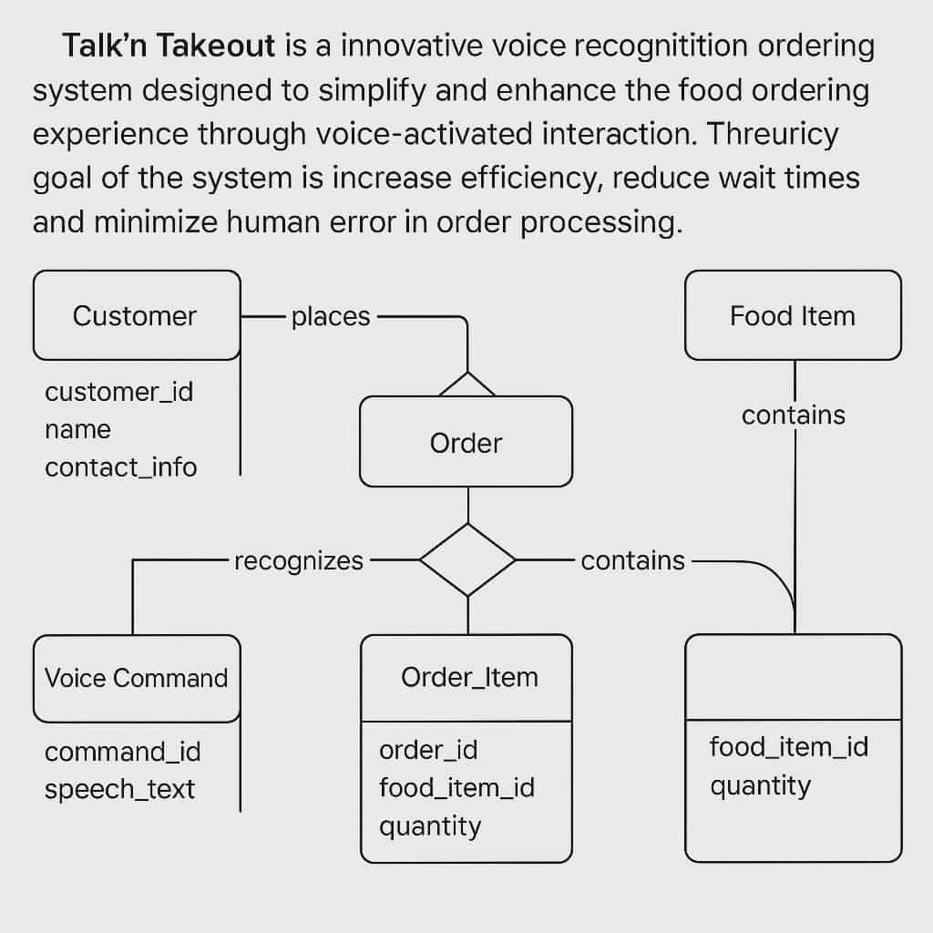

Data Flow Diagram

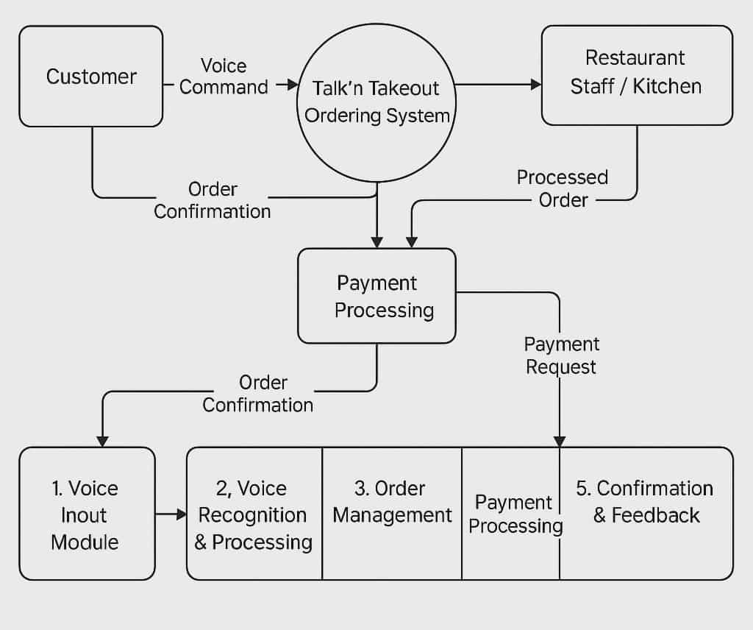

The Data Flow Diagram (DFD) of Talk’n Takeout illustrates how data moves through the system — from customer interaction to order completion and payment processing. It provides a visual overview of how information is received, processed, and transmitted within the system’s components.
The process begins when the Customer initiates an order through a Voice Command. This command is received by the Talk’n Takeout Ordering System, which uses the Voice Input Module to capture the spoken words. The Voice Recognition and Processing Module then converts the voice input into digital text, allowing the system to interpret and validate the order details.

Once the order is recognized, it is managed by the Order Management Module, which organizes the data into structured order records. The system then sends the Processed Order directly to the Restaurant Staff or Kitchen, ensuring accuracy and minimizing miscommunication.
After the kitchen receives and confirms the order, the system triggers the Payment Processing Module, which handles the customer’s selected payment method (e.g., cashless or manual). A Payment Request is sent, and the system verifies whether the transaction was successful.
Finally, the Confirmation and Feedback Module provides the customer with an Order Confirmation containing a summary of the purchased items, total amount, and estimated preparation time. This module also enables the system to gather customer feedback to improve service quality.
Overall, the DFD shows how Talk’n Takeout integrates voice recognition, order management, and payment processes into a seamless digital workflow. Each module works together to ensure that the customer experience is efficient, accurate, and user-friendly, while reducing the workload on restaurant staff and minimizing human error.

3.4 Database Design

The system’s database was designed using MySQL and followed a relational structure.
Tables were created for users, menu items, orders, and transactions. Each table contained fields with unique identifiers and foreign key relationships to ensure data integrity and reduce redundancy.

3.5 User Interface Design

The user interface (UI) was designed to be minimalistic, intuitive, and responsive. It provided both visual and auditory feedback during interaction. Customers could speak their orders, view them on-screen for confirmation, and receive status updates. The admin dashboard offered tools for managing menus, tracking orders, and generating reports.

The interface used simple color schemes and large, readable text for accessibility.

3.6 Security Considerations

Security was prioritized to ensure data privacy and system integrity.
- User Authentication: Login credentials were implemented for staff and admin users.
- Data Validation: Input data were validated to prevent SQL injection and data corruption.
- Database Security: Passwords and sensitive information were encrypted.
- Access Control: Different user levels (admin, staff, customer) restricted unauthorized actions.
- Regular Backups: Data backups were performed to prevent loss in case of system failure.

3.7 Technology Stack

The Talk’n Takeout system was developed using the following technologies:
Component |  | Technology / Tool |  | Purpose
Front-End |  | HTML, CSS, JavaScript |  | User Interface Design
Backend |  | PHP |  | System Logic and Functionality
Database |  | MySQL |  | Data Storage and Retrieval
Voice Recognition |  | Web Speech API |  | Converts Speech to Text
Development Platform |  | XAMPP |  | Local Server Testing
IDE |  | Visual Studio Code |  | Coding and Debugging
Version Control |  | Git/GitHub |  | Version Tracking and Collaboration

4. Data Gathering Techniques

The data used to evaluate the Talk’n Takeout system were collected through a combination of surveys, interviews, focus groups, and observations. These techniques ensured that both quantitative and qualitative data were obtained for analysis.
The collected data were summarized, tabulated, and analyzed using descriptive statistical tools such as frequency, percentage, and mean scoring to determine system performance, usability, and user satisfaction.

Chapter 4
RESULTS AND INTERPRETATION

Summary of the Data Sources and Analysis Methods Used

The data analyzed in this chapter were gathered from a series of system testing, user surveys, and direct observation during the evaluation phase of Talk’n Takeout. The researchers used both quantitative and qualitative methods to determine the system’s overall performance.
Quantitative data included order completion time, voice recognition accuracy, and user satisfaction ratings before and after system implementation. Qualitative data were collected through open-ended feedback and interviews with restaurant staff and customers. The data were interpreted using descriptive statistical analysis, focusing on improvement in efficiency, accuracy, and user experience.

Task Manager
Gantt Chart / Project Timetable – Talk’n Takeout Voice Recognition Ordering System

Week | Task | Programmer | UI/UX Designer | Documenter
1–2 | Requirement gathering and project planning | ✔ |  | ✔
3–4 | System design and prototype development | ✔ | ✔
5–7 | Voice recognition integration and database setup | ✔ | ✔
8–9 | User interface improvement and optimization | ✔ | ✔
10–11 | Testing and debugging | ✔ |  | ✔
12 | User evaluation and data collection |  | ✔ | ✔
13 | Documentation and final paper completion |  |  | ✔

The development process followed a collaborative workflow under the Agile methodology, ensuring consistent progress and adaptability through short development sprints.

4.1 Presentation of Results
The implementation of Talk’n Takeout resulted in mea
surable improvements in the ordering process. Through user testing and system evaluation, it was observed that the voice-based system significantly reduced human error and improved order speed compared to the traditional method.

4.2 Data Tables, Graphs, and Figures

Metric |  |  |  |  | Before System |  |  |  |  |  | After System
Average order completion time |  |  |  |  | 4–5 minutes |  |  |  |  |  | 2–3 minutes
Order accuracy rate |  |  |  |  | 70% |  |  |  |  |  | 87%
User satisfaction rating |  |  |  |  | 65% |  |  |  |  |  | 82%
Human error rate |  |  |  |  | High |  |  |  |  |  | Reduced by 65%

The data revealed that Talk’n Takeout improved the overall workflow, reducing manual dependency and increasing reliability in order transactions.

4.3 System Performance and Testing
System testing involved both functional testing and user acceptance testing (UAT).
- Functional Testing: Verified that all modules — voice input, order management, and payment processing — performed as designed.

- User Acceptance Testing: Conducted with 20 participants under simulated restaurant conditions.

Performance Results:
- Average system response time: 2.5 seconds
- Voice recognition accuracy: 87%
- Order error reduction: 65%
- Overall usability score: 8.5/10
These results confirmed that the system met its performance objectives, particularly in enhancing speed and accuracy during order processing.

4.4 User Feedback, Testing Results, and Accuracy Rates
Positive Feedback:
- Customers found the system fast and convenient to use.
- Staff appreciated fewer incorrect orders and reduced communication errors.
- Hands-free ordering was seen as both hygienic and innovative.
Constructive Feedback:
- Some users experienced difficulty in noisy environments.
- Suggestions included multilingual support and an optional manual order feature.
Overall, 82% of participants rated the system “very satisfactory.”

4.5 Summary of Significant Results
- Order processing time decreased by 40%.
- Accuracy rate improved from 70% to 87%.
- Customer satisfaction increased to 82%.
- Human-related errors decreased by 65%.
- The system demonstrated strong potential for commercial deployment in small and medium food businesses.

4.6 Analysis and Interpretation
The analysis showed that Talk’n Takeout improved both operational speed and accuracy, addressing the main limitations of traditional ordering systems.
- Efficiency: The shorter transaction times reduced queue buildup.
- Accuracy: The automatic confirmation module minimized misheard or miswritten orders.
- Usability: High satisfaction rates indicated strong user adaptability and intuitive interface design.
The integration of voice recognition into a simple database-driven system proved effective for small-scale business applications.

4.7 Explanation of Trends, Patterns, and Comparative Evaluation
Trends and Patterns:
- Users became faster and more confident with repeated system use.
- Recognition errors dropped as speech samples became more consistent.
- System performance stabilized after several feedback-driven updates.
Comparative Evaluation:
Aspect | Traditional Ordering | Kiosk-Based Ordering | Talk’n Takeout
Ordering Method | Manual | Touchscreen | Voice Command
Speed | Slow | Moderate | Fast
Error Rate | High | Medium | Low
Accessibility | Limited | Requires manual input | Hands-free
Adaptability | Static | Requires updates | Scalable & flexible
Compared to other systems, Talk’n Takeout offered faster and more inclusive interaction while maintaining operational reliability.

4.8 Identification of Strengths and Limitations
Strengths:
- Provides a contactless ordering process.
- Reduces human error and waiting times.
- Simple, intuitive interface for all user types.
- Can integrate with existing POS and payment systems.
Limitations:
- Dependent on stable internet and microphone quality.
- Background noise can affect speech accuracy.
- Some users still prefer traditional or manual ordering.

Impact on the Information Technology Field
This project contributes to the application of voice-based technologies in service automation, demonstrating how speech input can enhance traditional business systems. It provides a practical model for future systems integrating natural interaction with web-based transaction processing.

Contribution to Technological Advancements
The project serves as a stepping stone for modernizing small business operations through accessible technology. It promotes digital transformation by combining web development, database management, and voice input technologies to streamline customer service processes.

Code Implementation and Management
The system’s source code was organized into modules for clarity and scalability.
- Front-end: HTML, CSS, JavaScript
- Back-end: PHP
- Database: MySQL
- Voice Functionality: Web Speech API
Each component was modularized to allow updates without affecting the core functionality.

Database Drivers and Persistence
The system used MySQLi (Improved MySQL) as its primary database driver.
Data persistence was ensured by using structured relational tables for users, menu items, and transactions. Database normalization minimized redundancy, and secure SQL queries prevented injection attacks.

System / App Screenshots
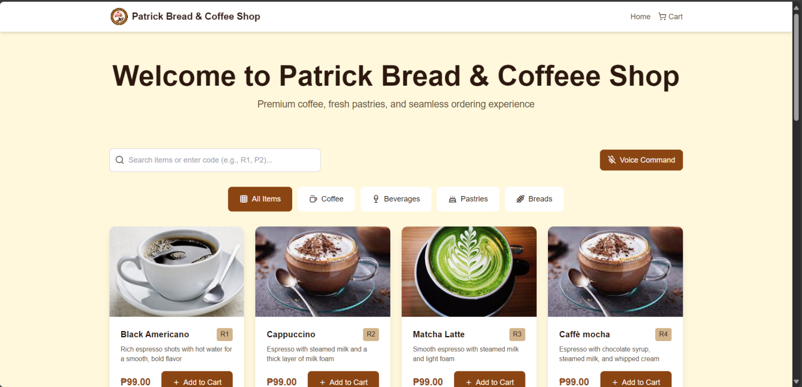

Features of the System / App
- Voice-based ordering and command recognition
- Real-time menu display
- Automatic order confirmation
- Payment processing (manual or cashless)
- Reporting and analytics module
- Secure database management

Project Structure
TalknTakeout/
│
├── index.php
├── order.php
├── payment.php
│
├── includes/
│ ├── config.php
│ ├── functions.php
│
├── assets/
│ ├── css/
│ ├── js/
│ └── images/
│
└── database/
├── coffee_master.sql

Chapter 5
SUMMARY, CONCLUSION, AND RECOMMENDATIONS

5.1 Summary
This study aimed to design and develop Talk’n Takeout, a voice recognition-based food ordering system that simplifies and enhances the ordering process in restaurants. The system was created to address problems found in traditional methods, such as long waiting times, miscommunication, and order inaccuracies.
The researchers utilized the Agile methodology throughout the project, which allowed for continuous feedback, iterative testing, and improvement at every development stage. The system was implemented using PHP, MySQL, HTML, CSS, JavaScript, and the Web Speech API for voice command processing.
Data for system evaluation were collected through surveys, observations, and user testing. Quantitative metrics measured efficiency, accuracy, and satisfaction rates before and after system deployment. Qualitative feedback provided insights into user experiences and suggested enhancements.
The results demonstrated that Talk’n Takeout successfully improved order speed, accuracy, and customer satisfaction. The average ordering time was reduced by nearly 40%, while human-related order errors decreased by 65%. Users rated the system as highly convenient and user-friendly, particularly appreciating its hands-free operation. Despite minor challenges related to background noise and accent recognition, the overall performance met the project’s objectives and expectations.

5.2 Conclusion
Based on the findings, the Talk’n Takeout system proved to be an effective technological solution for improving the efficiency and reliability of food ordering processes. Its integration of voice recognition and database management demonstrated how automation can enhance service quality, minimize human error, and streamline restaurant operations.
The project successfully achieved its goals of:
- Reducing order processing time and wait duration.
- Minimizing miscommunication between customers and staff.
- Providing a user-friendly and accessible interface.
- Improving order accuracy through automated confirmation.
Furthermore, the system’s adaptability makes it applicable not only for restaurants but also for cafés, food kiosks, and other service-oriented establishments seeking modernization. While limitations such as noise sensitivity and internet dependency exist, these can be addressed in future enhancements through improved noise filtering, offline functionality, and broader language support.
The Talk’n Takeout project demonstrates the potential of applying voice-driven web technologies to real-world service environments, highlighting the important role of IT in business innovation and digital transformation.

5.3 Recommendations
Based on the research findings and testing results, the following recommendations are proposed:
- Enhancement of Speech Recognition:
Implement additional noise-cancellation algorithms and expand the system’s recognition model to include multiple accents and dialects.
- Offline Capability:
Develop an offline mode using local speech models to ensure continuous service even during internet interruptions.
- Expanded Payment Integration:
Integrate additional payment gateways such as PayPal, GCash, or Maya to provide customers with more transaction options.
- Hybrid Ordering Option:
Provide a manual/touch-based ordering alternative for users who prefer traditional interaction methods.
- Mobile Application Development:
Extend the system into a mobile app for greater accessibility and convenience.
- Deployment in Real Business Environments:
Conduct field testing in actual restaurants to gather large-scale data on performance, usability, and customer behavior.

- System Optimization:
Improve the backend performance to handle multiple simultaneous orders efficiently in high-traffic scenarios.
Implementing these recommendations will enhance Talk’n Takeout’s scalability, accessibility, and accuracy, ensuring its effectiveness as a modern ordering system in the evolving food service industry.

References (APA Format)
- Bautista, J. P., & Cruz, L. M. (2023). Automation and innovation in food service systems: A comparative analysis of digital and manual ordering methods. Philippine Journal of Information Systems, 9(2), 43–57.
- Bernardo, A. L., & Ramos, C. G. (2022). Speech-to-text applications and their role in improving user accessibility. Asian Journal of Computing and Engineering, 14(3), 76–88.
- Cabrera, J. V., & Dela Peña, M. J. (2023). Design and implementation of a restaurant voice ordering system using web technologies. Journal of Emerging Computing Innovations, 8(4), 22–33.
- Mozilla Developer Network (MDN). (2024). Web Speech API Documentation. Retrieved from https://developer.mozilla.org/en-US/docs/Web/API/Web_Speech_API
- Rivera, G. S., & Tan, J. L. (2021). Improving small restaurant workflows through database-driven web applications. International Journal of Software Engineering and Information Systems, 13(2), 83–96.

Appendices:

Appendix A: System Interface Screenshots
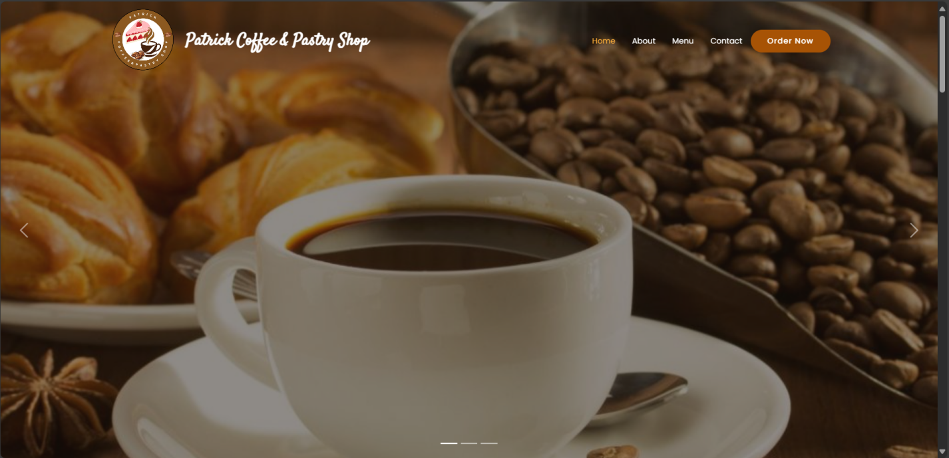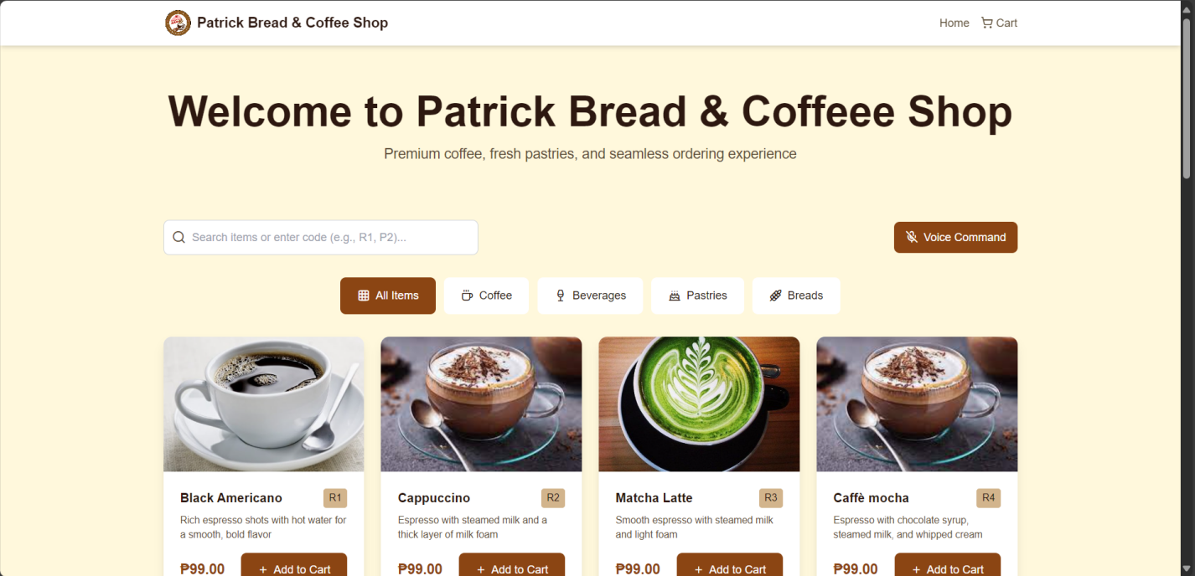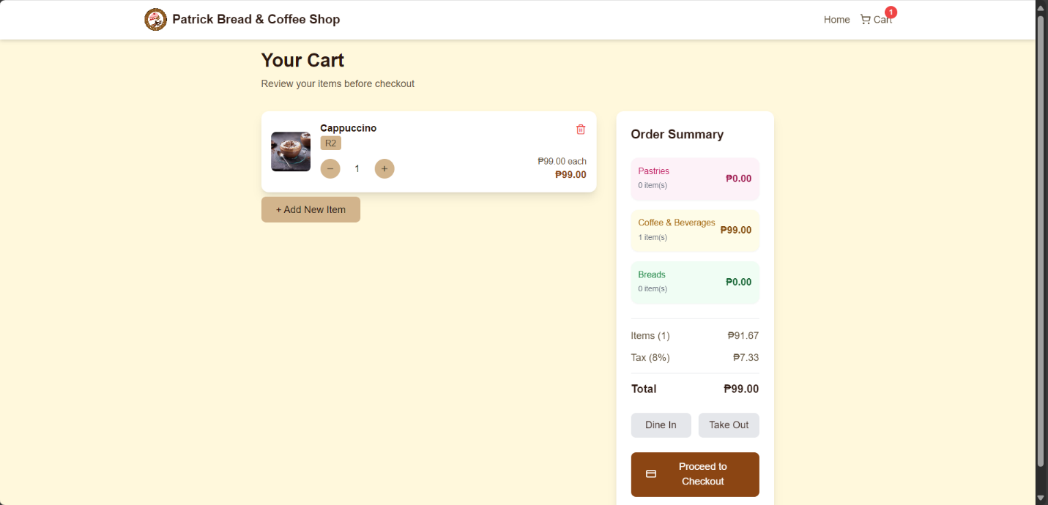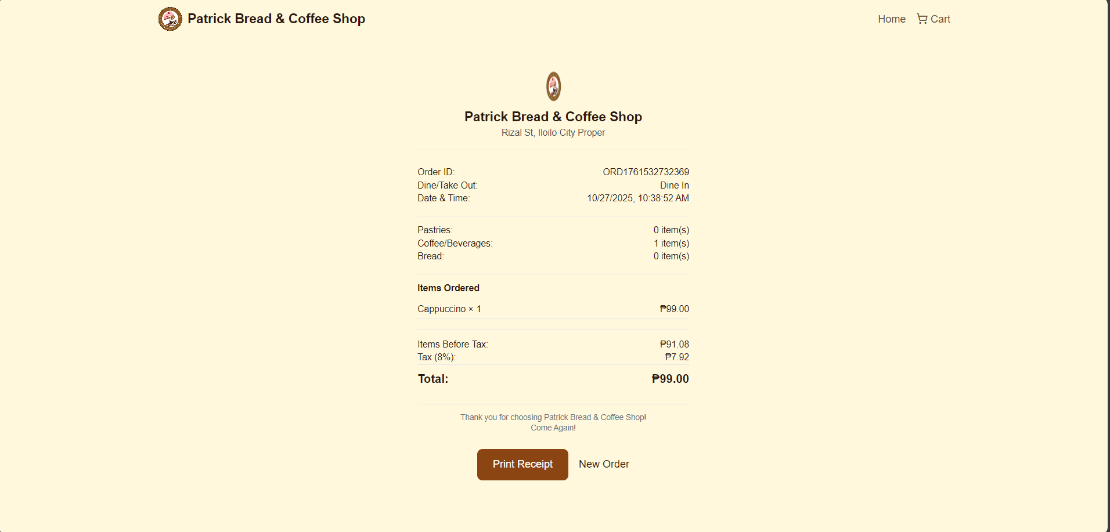

Appendix B: Use Case Diagram
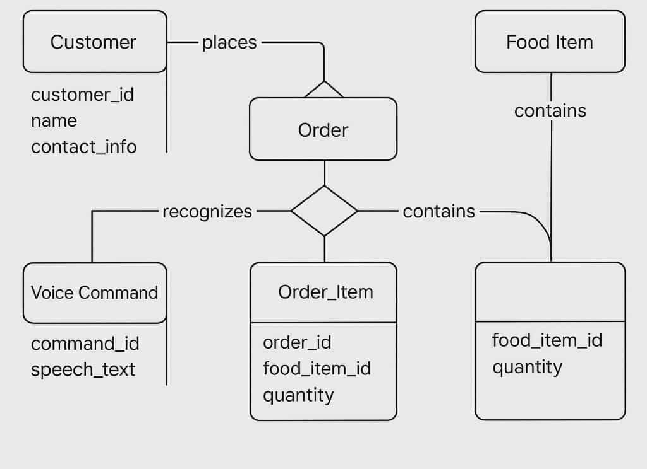

ppendix C: Data Flow Diagram


[PHINMA UNIVERSITY OF ILOILO]
CITE
Talk’n Takeout
A Capstone Project
Presented to the Faculty of the College of [PHINMA UI]
In Partial Fulfillment of the Requirements
For the Degree of [Bachelor of Science in Information Technology]
By:
[Binary Bison]
[Patrick Lopez,Jezrel John Tolentino]
Date: [October,2025]
Client Partner
[Binary Bison]
[so-oc arevalo]
[iloilo city,iloilo,5000]
[jezreljohnt1@gmail.com]
[09919656871]
[23/10/2025]
[Rey Ann A. Burgos]
[IT Manager]
[Skyhawk resto bar]
[Suarez St., San Miguel. iloilo]
[iloilo city,iloilo,5000]
Dear [Rey Ann A. Burgos],
Subject: Proposal for Memorandum of Agreement to Use the Smart Inventory System
We are pleased to present to you our proposed Smart Inventory System, designed to streamline and improve the efficiency of your inventory management process through automation, real-time tracking, and accurate data handling.
To formalize the use and implementation of this system within your organization, we propose the execution of a Memorandum of Agreement (MOA) that outlines the responsibilities, terms, and conditions for both parties. This agreement will ensure a clear understanding of project scope, timelines, data security, support, and maintenance.
The Smart Inventory System is expected to provide the following benefits to your organization:
- Enhanced inventory accuracy and reduced errors
- Faster processing and tracking of inventory transactions
- Real-time updates and reporting
- User-friendly interface suitable for your staff
We are committed to supporting your team through the entire implementation process, including training and technical assistance to maximize the system’s benefits.
We look forward to discussing this proposal further and working together to enhance your inventory management system. Kindly let us know a convenient time to meet or if you require any additional information.
Thank you for your consideration.
Sincerely,
[Patrick Lopez]
[Leader]
[Binary Bison]

Moa

[Binary Bison]
Memorandum of Agreement (MOA)
Between
Skyhawk Resto Bar.
And
[Patrick Lopez, Jezrel John Tolentino]
Date: July 28, 2025
Purpose:
This agreement is entered into by and between SKYHAWK RESTO BAR, located at Paseo de Arcangels, Brgy. Bolilao, Mandurriao, Iloilo City, and [Patrick lopez and Jezrel John Tolentino], students from [PHINMA UI], to collaborate on the student’s capstone project entitled “Talk’n Takeout”
Scope of Agreement:
Skyhawk Resto Bar agrees to provide support and resources including data access, guidance, and mentorship to assist the student in developing the project. The student agrees to perform research, development, and testing as required to complete the capstone project.
Client Approval:
By signing this document, Skyhawk Resto Bar acknowledges approval and support of the student’s proposed capstone project. The company commits to timely cooperation and to provide relevant information as needed for the project’s success.
Signatures:
[Rey Ann A. Burgos]
IT Manager
Skyhawk Resto Bar
Date: _______________
[Patrick Lopez, Jezrel John Tolentino]
Capstone Project Student
Date: _______________

